Basic Requirements Of a Quality Manual
by Kevin R. Grimes

In 50 Words Or Less
- If your quality management system is based on ISO 9001, your manual should reflect its requirements but doesn't need to match the format.
- A sample cover page, index, revision log introduction and definition page, along with two examples of quality policies, can help you get started.
The following article is adapted from chapter two of ISO 9000:2000: A Practical Quality Manual Explained by Kevin R. Grimes, which was published in 2003 by ASQ Quality Press and covers all eight clauses of ISO 9001.
If you are implementing a quality management system (QMS) based on the ISO 9000:2000 series of quality management standards, then the content of your quality manual should reflect the requirements of ISO 9001, though it does not need to match the format.
This is a simple statement, but you would be amazed at how many companies write manuals that are supposedly based on ISO 9001 but do not reflect the requirements.
One of the basic tenets of ISO 9001 or of any quality system is:
Say what you do,
Do what you say.
These two statements are not mutually exclusive, but many companies tend to say one thing and then do something completely different.
In most cases, ISO 9001 does not ask you to do anything you are not doing already; it merely asks you to document those actions. However, that documentation can be a problem. This article provides sample pages from an ISO 9001:2000 quality manual.
Because the examples apply to as many industries as possible, there are several things in them you may not necessarily need. Where possible, this will be indicated. And, even though the requirement may not apply to your organization, you must still state why it doesn't. This way, the registrars know you have looked at the requirement and made a determination. If you do not comment on the exclusion, the registrars will assume you simply ignored it and give you a nonconformance.

Some Simple Statements
When you are writing a quality manual, certain simple statements can save a lot of trouble. A statement such as "Quality records may include, but are not limited to, the following" can prevent your having to change the manual every time there is a minor alteration. In this instance, if you use a document that is not on your list as a quality record, you do not have to make a change to the documentation by completing the document change request (DCR) to include it. This can be useful if you are undertaking trials or tests; it may be considered a temporary change and not need to be documented until a final decision is made. If you are using the document on a regular basis, though, it would be wise to complete the DCR.
Under clause 4.2.3, control of documents, stating "Typographical errors and minor editorial changes are not considered changes for the purposes of this procedure" keeps you from having to complete a DCR every time you find a spelling error.
If you use the word "all" in the text (for example, "all employees"), make sure you really mean all. If there are exceptions, either state them or use different language. Under incoming inspection, companies frequently state all items entering the company's premises are inspected. The first question should then be, "Who is responsible for inspecting the paper clips that are purchased and enter the company's premises?"
Another important aspect of the quality manual is the tense in which it is written. Most people write as they speak, so the phrase "Nonconformances will be documented by the quality manager" seems acceptable. But this may not be acceptable to your registrar and could cause rejection of the documentation simply because it is written in the future, not the present, tense. The word "will" is future tense and indicates you will do this action at some future point in time. The quality manual should be written to reflect what you do now. Say, "Nonconformances are documented by the quality assurance coordinator."
While the sample manual pages in this article are written for a fictitious company, KRG Machine Works Ltd., they could easily be applied to service industries. In many instances the requirements and procedures are the same or similar. Simply change the wording slightly to correspond with what you want to say and how it applies to your processes.
The sample manual I propose is written as a single document describing the QMS. Previous convention was that there should be two manuals--one for policies and one for procedures.
The thinking was the policy manual could be used as a marketing brochure. Consequently, it tended to contain little information about what you actually did. It was more about what you planned to do. If a potential customer asked to see your quality manual, this was what you sent because you didn't want everyone to know how your company worked and the details of your processes. The details were contained in the procedure manual, which generally never left the company premises.
Most people are now aware of the ISO 9000 system. If customers ask, telling them you are certified to ISO 9001 and, if necessary, sending them a copy of your certificate will usually suffice. For this reason, the two manuals have been combined into one document.

Similar Wording
As you look through the sample manual and read it in conjunction with ISO 9001, you'll note similarities in the wording. I did this for two reasons:
- Why reinvent the wheel? If the standard requires you to do something, then say you do it. The wording used in the standard is fine, so why change it? However, you must understand what it is asking and why. Remember to say what you do, and do what you say.
- It makes the manual easier to follow for your colleagues, the registrars or personnel in other companies. If you do not follow the standard's layout, you should provide a matrix that cross-references the standard's clauses to your manual's layout.
If you are starting from scratch, following ISO 9001's format would be the recommended approach. If, on the other hand, you have documented procedures within your company, then it may be easier to build the manual around them as long as the manual has the standard's six required procedures and other documents that match the processes defined under clause 4.1 and the quality manual requirements of clause 4.2.2.
Alternatively, you could write some short procedures using the ISO 9001 numbering system and reference your specific procedures where they are applicable. If your procedures have been around for a while, verify they are still correct. Processes change, but the documentation tends to get left behind.
The preceding particularly applies if the procedures contain references to where information or documents can be found in computer files. Experience shows such references are rarely updated, so organizational newcomers have a difficult time finding things. (This is why updates should be processed through one person.)
In some instances, notably clauses 4.2.1 and 7.1, the standard refers to how you should plan and control the processes of your QMS--in other words, know what you are going to do and what you hope to achieve before you do it. You could eliminate the text dealing with this requirement since how you plan, implement and control your processes is dealt with elsewhere in the system. But my preference is to include it and reference where the requirements are documented.
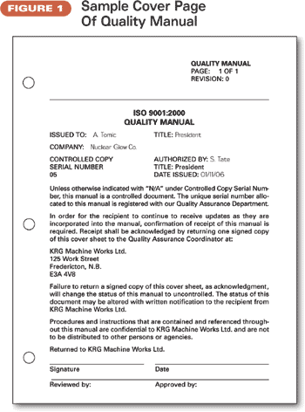

Figure 1 is a sample of how the cover page to your manual could look. The layout of the front cover is completely your choice, but some of the things to consider are:
- Pagination.
- Headers.
- Revision identification.
- Section numbering.
- Body of page.
- Control of documents.
- Reviews and approvals.
Pagination is important because it identifies how many pages there are in a specific section of the document. It is then easy to determine whether any pages are missing.
If your manual is a complete, bound document, from which individual pages cannot be detached, you may not need to identify each page separately. But, if you change anything in the manual (and you will), then you may have to reissue the whole manual every time. For example, if you change page two in a 100-page document and it flows over to page three, then it may affect all of the other pages and you would have to reissue the whole document.
By paginating each section separately, you minimize reprinting. It is far more economical to identify the separate sections and pages within a section with a header and reissue only the required pages or sections. If your manual is online, you will only have to repaginate the affected section.
Headers. In the header section of the page, the blank space on the left side is left for companies to insert their corporate logo or letterhead, if desired. The header "Quality Manual" identifies the document. For brevity, the header, which should appear on all pages, is not repeated throughout the text.
Revision identification. ISO 9001 clause 4.2.3, control of documents, states a documented procedure shall be established to define the controls needed to ensure changes and that the current revision status of documents is identified. One method is to identify the revision on the document. Hence, "revision 0" in the example indicates an original document with no changes.
At this point you need to determine how you are going to number your documentation's revisions. For example, if you have a section with six pages and you revise only page four, not affecting any of the other pages, is just page four changed to "revision 1" or is the whole section changed? Either choice is acceptable, but for ease of control, I recommend you change the revision identification of the whole section. If the revision code is embedded into a header, it will automatically change on all the other pages if you change it on page four.
You could alternatively use the date as a revision code. This works well on most documents, but can sometimes be a problem with drawings. Depending on your type of business, you could issue two or three versions of the same drawing in one day. At this point, you would need to include a time stamp, or you could also claim the drawings were works in progress. As long as they are not signed as approved, it is not necessary to identify the latest revision other than the one currently in the computer system.
Section numbering. The section numbering method is a matter of choice. In the examples in this article, section numbers 0 to 3 have been added so they take us up to Section 4 and correspond to the ISO 9001 numbering system. But remember there is no requirement to follow the ISO 9001 numbering system. It is merely a matter of convenience.
Body of page. The rest of the page is a matter of personal choice. Identify the quality system it applies to--for example, ISO 9001:2000--and that it is the quality manual as opposed to any other document that may be applicable to the QMS.
Control of documents. Quality documents should be controlled if they are to be adequately updated, so it is useful to identify to whom the documents are issued. This control also includes a separate number for each copy and identifies who authorized the release of the controlled document. There should be a handwritten or electronic signature for each copy issued.
The additional text in Figure 1 is optional but is also a measure of control when you send out revisions to the manual, particularly external copies. It ensures you get confirmation the changes have been received. The additional language may not be necessary in a small company where you can hand deliver the changes and make sure they are incorporated into the manual or where the authorized version of the quality manual is accessible on the company intranet.
Normally, it is recommended you keep copies to a minimum. Any external document you may send to a client should be identified as uncontrolled, so you do not have to update it.
Reviews and approvals. The footer, which appears on every page of the document, ensures each page has been reviewed, generally by the quality assurance coordinator, and approved, generally by the president or CEO of the organization.
The quality assurance coordinator's name can be typed, but the CEO's signature should be handwritten on every page, indicating each page has been approved. This signature can be inserted electronically if required, a proviso being that you should be able to show only the signature holder can do this.
It is not strictly necessary for every page to be signed, but you must show there is control over the revisions. For example, if the changes to the manual are authorized, then you can argue that the manual is authorized in its entirety by default.

Index
While it is not strictly necessary to have an index, it is useful for those who are not familiar with the layout and numbering system of ISO 9001:2000. The measure of detail is your choice, of course, but I recommend you go to at least two levels, as shown in Figure 2.
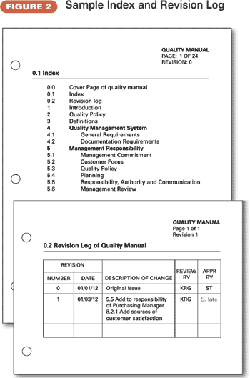

Revision Log
The revision log, shown at the bottom of Figure 2, identifies the changes made to the quality manual. Other methods include indicating the changes to the text within the text, either by highlighting them in some form or by indicating changes in the margins.
Neither of these methods, however, would track a series of changes. Each would, instead, disappear at the next revision. The revision log method provides a continuing record of changes. The DCRs, of course, give a more detailed track of the information changed and can be referenced.
As you progress through a series of revisions, the initials of the reviewers and approvers can be typed, except on the last version, provided you keep the original copy of each as a record.
As stated earlier, it is not necessary for the CEO to sign every page of every manual you issue, though the cover page should be signed as authority to release that specific revised document. If you have a large number of copies, it would probably take you weeks to get them back from his or her desk, and you could be looking for another job real soon.
All you need to have signed is an original copy, which you should keep safe. Everything else, except the first-page authorization for each copy, can be photocopied. This first page must be returned so you can verify those responsible are updating their manuals as required.
You can have more than one section revised under one revision number, and the revision number on the revision log should be the same as that on the front page of the manual.

Introduction
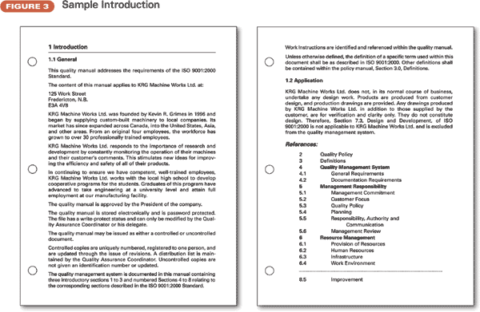

Section one, the introduction to the quality manual (see Figure 3, p. 26), should give a brief description of what it is about and a little history of your organization.
The first paragraph should say the quality manual addresses the requirements of ISO 9001:2000 as opposed to any other standard. It is important you state this somewhere within the quality manual; otherwise, neither you nor your customers have a reference against which to judge the manual's contents.
The next paragraph should state the location of the organization to which the manual applies. This is important in determining whether your organization has more than one location and whether the manual applies to all or only some.
A brief description of the company should be included. It is not necessary to go into too much detail. Who you are, where you are and what you do are sufficient. Potential customers who are reading this will already have some information, so do not treat the introduction as a marketing brochure.
Any additional information you think may be of interest can be included, depending on your particular circumstances. Figure 3's example includes information about the constant monitoring of installed equipment and a cooperative program with the local high school.
A summary of what the quality manual contains follows so people reading the manual for the first time will gain some idea of its contents and application.
A statement that the quality manual is approved by the president of the company indicates the contents have the full backing of the president and are to be taken seriously.
The introduction should indicate the quality manual is protected from unauthorized change through passwords and its distribution is controlled to ensure it can be updated as required and that every controlled copy is current.
The layout of the quality manual is also described. In this case it is linked to the clause numbering and naming system in ISO 9001:2000. I reiterate this is not a requirement of the standard but makes it easier to discuss the quality manual or standard with people from other companies.
Any additional information in the manual may be identified here. The example in Figure 3 says work instructions are identified and referenced in the quality manual. This means they are documented elsewhere and not contained within the manual but should still be controlled documents.
The sample says the terms used are the same as those defined in the vocabulary of ISO 9001:2000 except for those defined in section three, definitions, of your quality manual. Any words that you have defined differently or that are specific to your industry or organization should be defined in section three.
Clause 1.2, application, of ISO 9000:2000 says you may exclude some parts of clause 7 if desired. This part of Figure 3 says KRG Machine Works Ltd. does not do its own design work and why. To this end, clause 7.3, design and development, does not apply.
If there are any other subclauses from clause 7 that you believe you can exclude, state that fact here. In the actual procedure in the quality manual, restate why. If all the clauses apply to you, state there are no exclusions under this standard.
A sample of references is included in Figure 3. In your actual manual you should include all the procedures (clauses) that apply or do not apply. I recommend you go to two levels (for example, 5.1, 5.2), but this is not a requirement.

Quality Policy
Section 5.3 of ISO 9001:2000 requires the organization to have a defined quality policy that is communicated and understood within the organization. This policy can be in any form you like but must be agreed on by senior management.
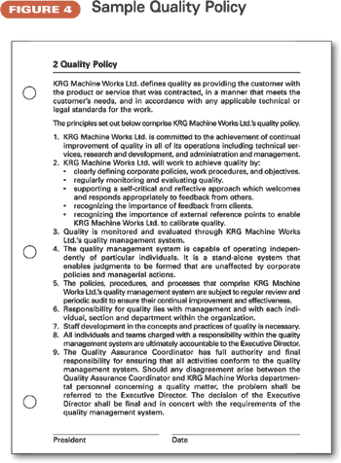
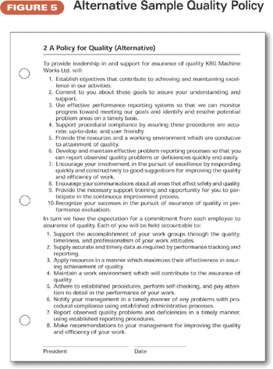

Two examples of policies (Figures 4 and 5) are shown. You are free to write your own policy, but if you are trying to save time by using one of these examples, read the text thoroughly and understand its implications. Your policy does not need to be as detailed as the examples, which are long because I've tried to provide as much information as possible.
Under the ISO 9001:1994 standard, the policy could be dealt with simply by stating in clause 4.1, general requirements, "It is the policy of KRG Machine Works Ltd. to manufacture equipment and parts of a quality that meets the needs and expectations of our customers. The management and employees are committed to achieving this policy through implementation of the quality system."
Registrars have increasingly pressed for a more detailed quality policy, because clause 5.3 of ISO 9001:2000 sets out additional requirements the quality policy must fulfill. The examples in Figures 4 and 5 fulfill all the requirements.
Communication and understanding seem to be the most difficult requirement to achieve, but they should not be. Communication of the quality policy can be by memo, e-mail or notice board posting. Understanding should be dealt with in the initial training sessions. Verification of this understanding can be checked through the internal audits. It is important to do this because registrars usually check for understanding during their audits.
Item five, which deals with the continued improvement and effectiveness of the QMS, is important. The quality policy should be reviewed at each management review to ensure it is still appropriate to the organization.
Item nine is important in that it defines the responsibility of the quality assurance coordinator in relation to the QMS.
It is also important the policy be signed by the CEO to show approval of the QMS from senior management.

Definitions
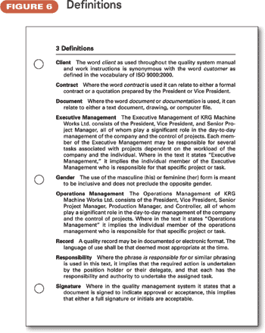

Any terms specific to your industry or company should be defined here (see Figure 6).
If you prefer the use of the term "client" to the term "customer," as is used in the standard, define it here.
The word "contract" is explained because some companies may issue a proposal, which, if accepted, requires no other formal contract. A verbal agreement may form a contract.
The difference between executive and operations management should be defined if it is applicable. For example, executive management may set the general policies of the company, and operations management may implement them.
The aim of the gender definition is to avoid having to repeat the phrases such as "his or her" over and over again. You can use his, her or their in the main body of the text, and all the meanings are covered.
The definition of the word "responsibility" is important to avoid having to type repeatedly, for example, that the quality assurance coordinator is responsible for and has the authority to verify the actions required.
An auditor once issued a nonconformance to a company regarding its quality records. Although the organization had prepared a control of records table that showed the required records and the responsibility, the registrar said this did not include the authority to dispose of the records.
This example shows why it is important as many people as possible read the manual and ensure its contents are clear. Once the manual has been written and preferably before it is implemented, a training session for all employees can clarify such instances.

KEVIN R. GRIMES is president of Quality and Productivity Management, Fredericton, New Brunswick, Canada. He earned a bachelor's degree in social science from Open University, Melton Mowbery, England. Grimes is a member of ASQ and a certified quality manager.

